***FAKE NEWS DETECTION USING NLP***

***TEAM MEMBER***

***731721106016-SANGEETHA.D***

***PHASE-3 PROJECT SUBMISSION***

***PROJECT: Fake News Detection***



***INTRODUCTION:***

* ***Fake news detection is a critical task in today's information age. It involves the identification and verification of misleading or fabricated information presented as factual news.***
* ***With the proliferation of social media and digital platforms, the spread of fake news has become a significant concern, impacting public discourse and decision-making.***
* ***In this context, advanced technologies, such as natural language processing and machine learning, play a vital role in developing tools and algorithms to detect and combat fake news effectively.***
* ***This is a challenging and evolving field that aims to safeguard the integrity of information and promote responsible journalism in the digital era***

***CONTENT FOR PROJECT PHASE-3:***

***Consider the Utilizing advanced algorithms and data analysis to identify misinformation and disinformation in digital content.***

***DATA SOURCE:***

***Employing robust methodologies to assess the credibility and authenticity of information providers to enhance the accuracy of news verification processes.***

***DATA INFORMATIONS:*** <https://colab.research.google.com/drive/1AUOG_lw3OgZwbsa1sFXwhRZYF-rQvMmo?usp=sharing>

***SOURCE CODE:***

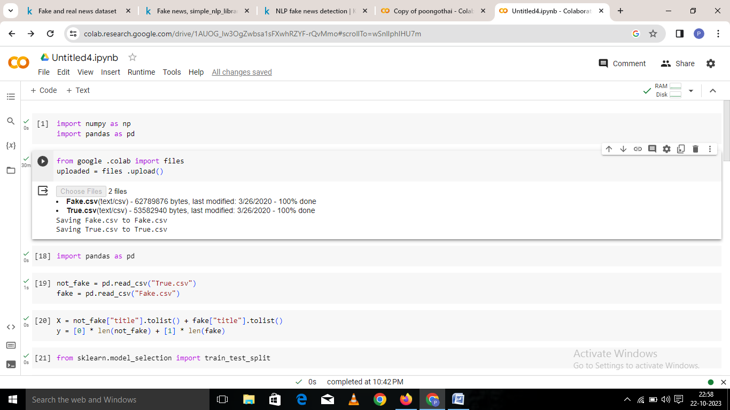

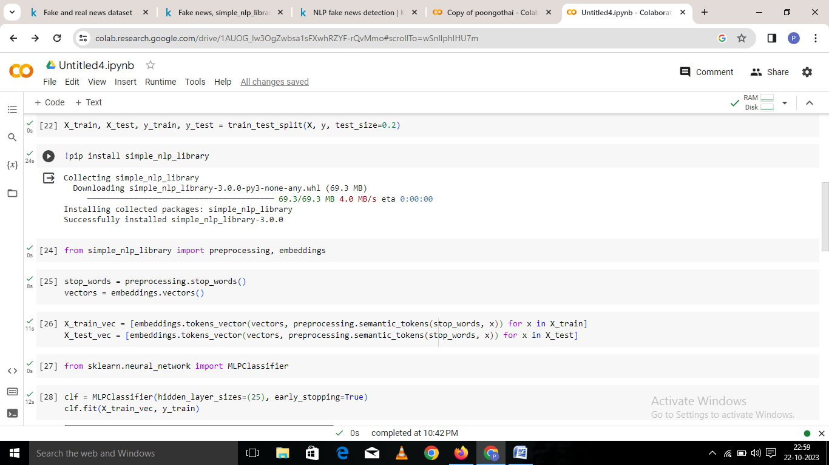

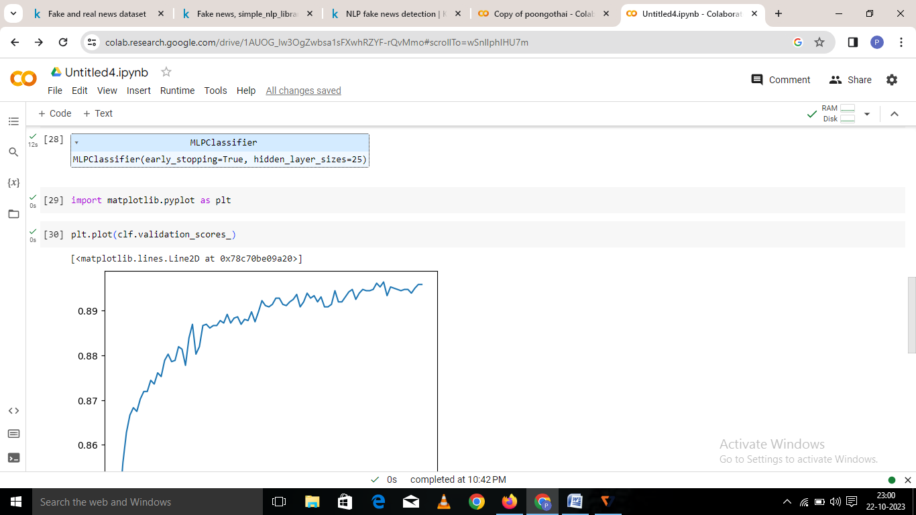

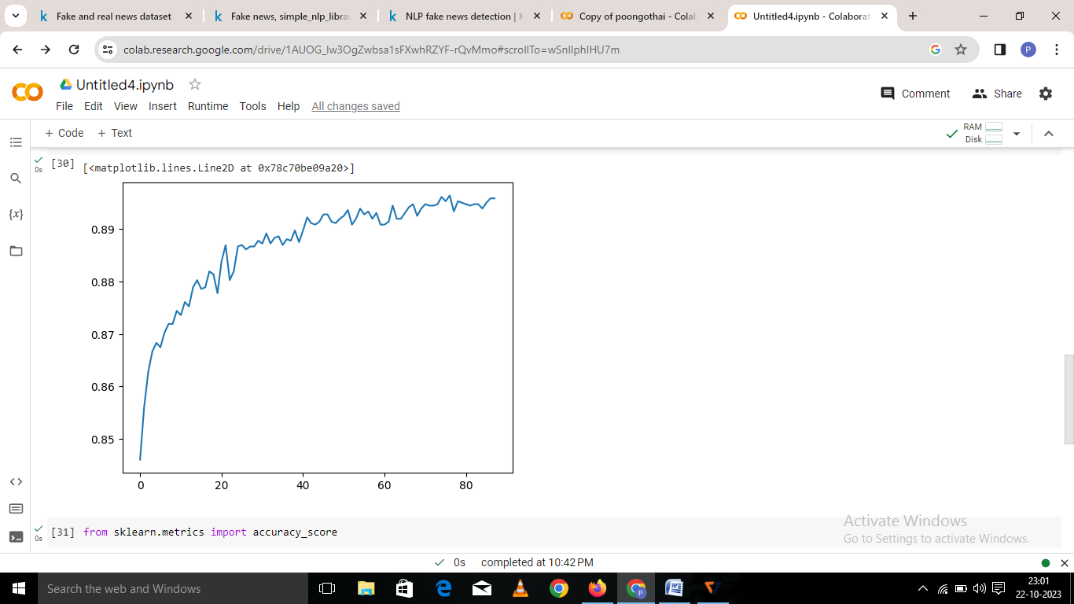

***DATASET LINK:***

[**https://www.kaggle.com/datasets/clmentbisaillon/fake-and-real-news-dataset**](https://www.kaggle.com/datasets/clmentbisaillon/fake-and-real-news-dataset)

***That’s all the informations we gathered…!***